**Assignment-4**

1. A. Create a LAN named IIIT Kalyani(10.0.0.0) as mentioned below –

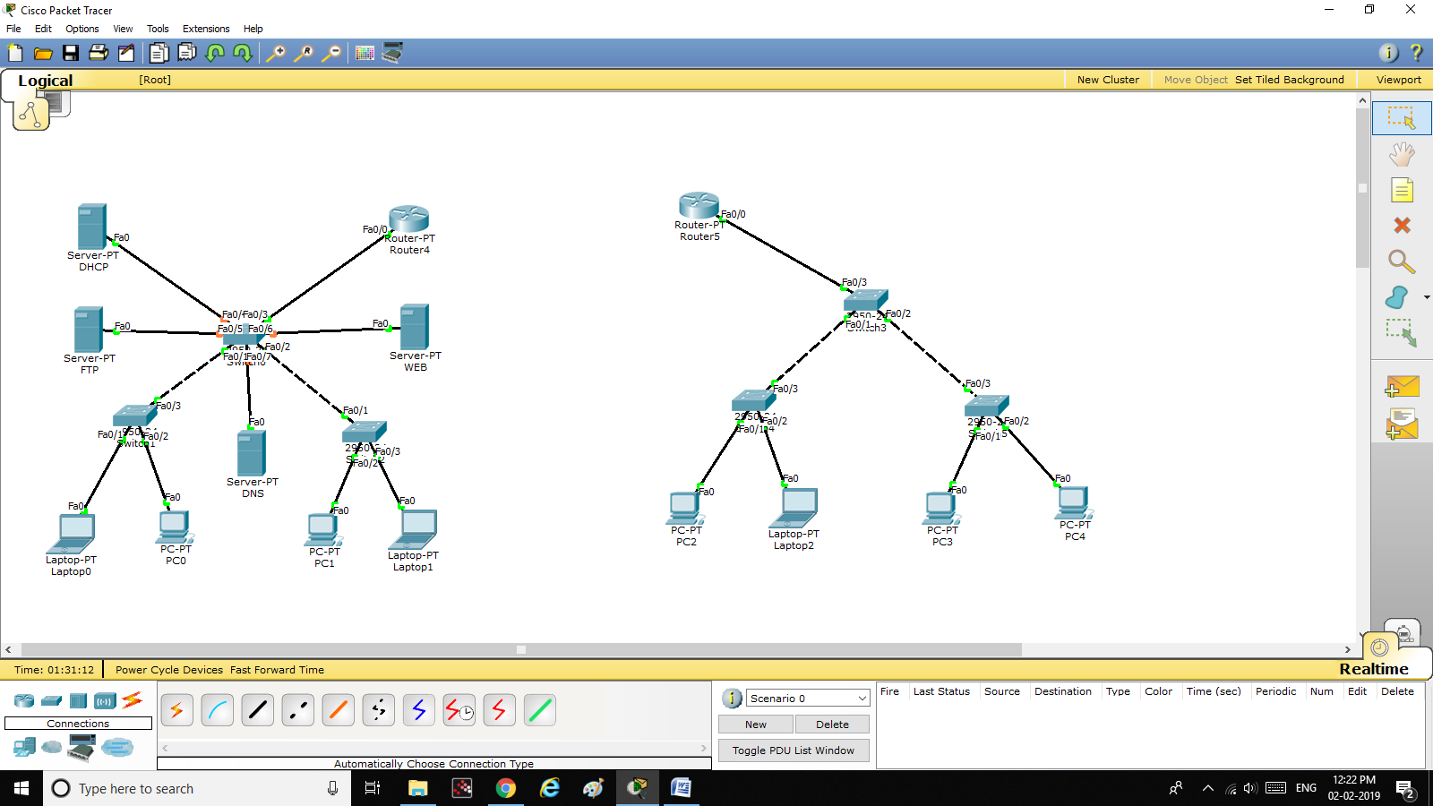

DHCP Server – IP: 10.0.0.51, Subnet: 255.0.0.0, DNS: 10.0.0.52, Default Gateway: 10.0.0.1

DNS Server – IP: 10.0.0.52, Subnet: 255.0.0.0, DNS: 10.0.0.52, Default Gateway: 10.0.0.1

FTP Server – IP: 10.0.0.53, Subnet: 255.0.0.0, DNS: 10.0.0.52, Default Gateway: 10.0.0.1

WEB Server – IP: 10.0.0.54, Subnet: 255.0.0.0, DNS: 10.0.0.52, Default Gateway: 10.0.0.1

Laptop0: IP - DHCP

PC0: IP – DHCP

Laptop1: IP – DHCP

PC1: IP - DHCP

Router(generic) – IP(FastEthernet0/0 – The LAN is connected to this Interface): IP:10.0.0.1, Subnet: 255.0.0.0, DNS: 10.0.0.52, Default Gateway: 10.0.0.1

B. Configure the DHCP server as mentioned above.

C. Configure the host PCs to obtain IP address from DHCP Server.

D. Configure the FTP server and web server

E. Configure the DNS server – create an Alice for web server (www.iiitk.ac.in)

F. Access the web page from any of the PC using [www.iiitk.ac.in](http://www.iiitk.ac.in)

G. Login to FTP server and upload and download file using `put` and `get` command.

1. A. Create another LAN named IIT KGP(20.0.0.0) as mentioned below –

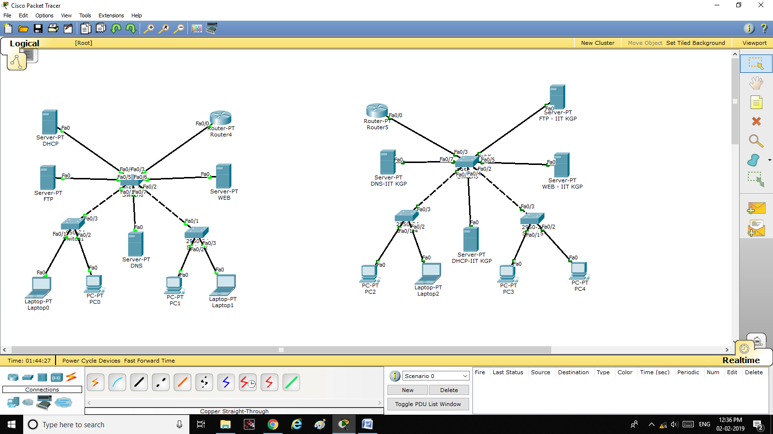

DHCP Server – IP: 20.0.0.51, Subnet: 255.0.0.0, DNS: 20.0.0.52, Default Gateway: 20.0.0.1

DNS Server – IP: 20.0.0.52, Subnet: 255.0.0.0, DNS: 20.0.0.52, Default Gateway: 20.0.0.1

FTP Server – IP: 20.0.0.53, Subnet: 255.0.0.0, DNS: 20.0.0.52, Default Gateway: 20.0.0.1

WEB Server – IP: 20.0.0.54, Subnet: 255.0.0.0, DNS: 20.0.0.52, Default Gateway: 20.0.0.1

PC4: IP - DHCP

PC3: IP – DHCP

Laptop2: IP – DHCP

PC2: IP - DHCP

Router(generic) – IP(FastEthernet0/0 – The LAN is connected to this Interface): IP:20.0.0.1, Subnet: 255.0.0.0, DNS: 20.0.0.52, Default Gateway: 20.0.0.1

B. Configure the DHCP server as mentioned above.

C. Configure the host PCs to obtain IP address from DHCP Server.

D. Configure the FTP server and web server

E. Configure the DNS server – create an Alice for web server (www.iitkgp.ac.in)

F. Access the web page from any of the PC using [www.iitkgp.ac.in](http://www.iitkgp.ac.in)

G. Login to FTP server and upload and download file using `put` and `get` command.

1. A. Connect the two router - FastEthernet1/0 of router4---------- FastEthernet1/0 of router5. As shown in the picture.

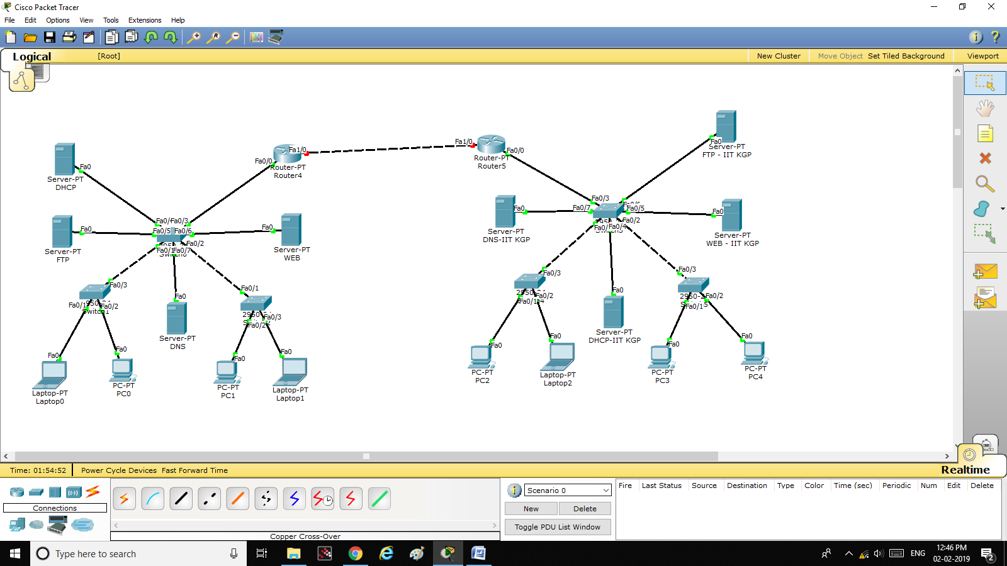

B. Configure the WAN Network as follows –

IP of FastEthernet1/0(router4) – 30.0.0.1

IP of FastEthernet1/0(router5) – 30.0.0.2

C. Ping from IIIT Kalyani network to IIT KGP network and check the status.

D. Configure Static route in both routers and ping again to check status.

E. Access the IIT KGP web server and FTP server from IIIT Kalyani network and vice-versa.

E. Delete all static route, Configure dynamic routing and execute point E again.

1. A. Add another router(Router6).

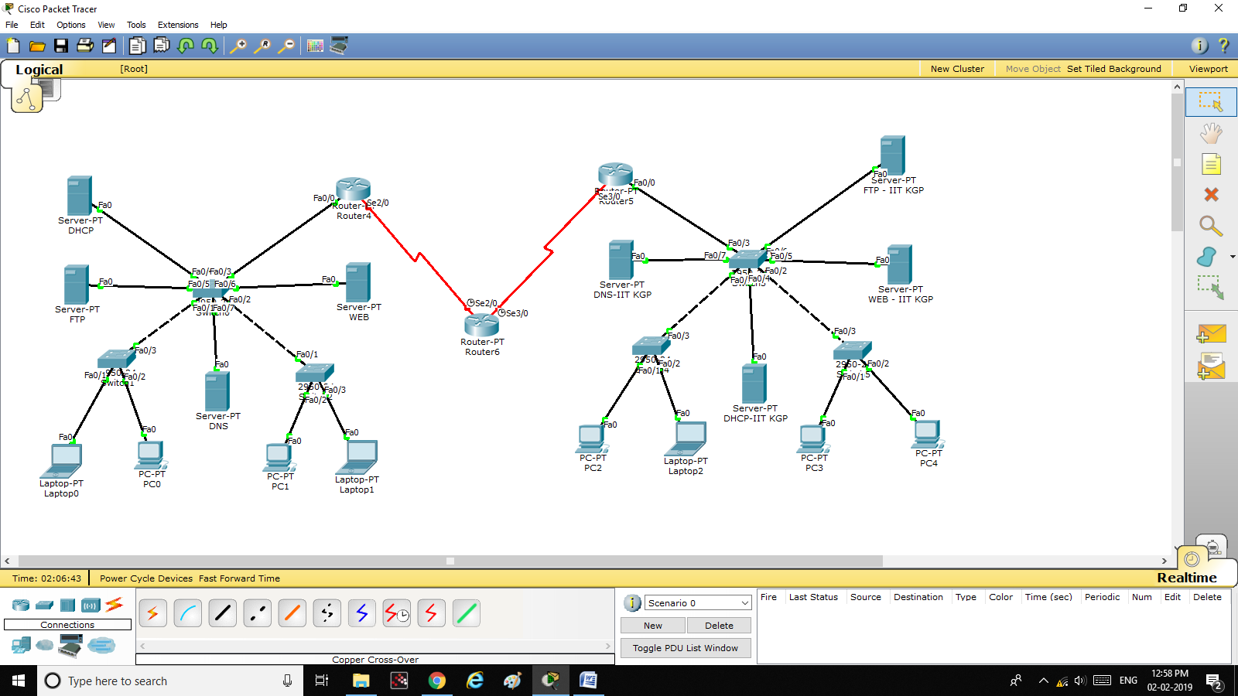

B. Connect Router4 and Router6 using Serial Port 2/0(of both router)

C. Connect Router5 and Router6 using Serial Port 3/0(of both router)

NOTE: Serial ports can be connected using serial(red colour) cable.

D. Assign IP address 40.0.0.1 to Serial2/0 of Router4 and 40.0.0.2 to Serial2/0 of Router6

E. Assign IP address 50.0.0.1 to Serial3/0 of Router5 and 50.0.0.2 to Serial2/0 of Router6

F. Remove link between Router4 and Router5. Delete all previous routes. Configure either Static routing and dynamic routing separately in Router4 and Router5 and Router6 to communicate from IIIT Kalyani LAN to IIT KGP LAN and vice-versa.

G. Re-execute 3.E.